Microcontroller Interfacing

# Specifications

## Connections:

### STM32F051C6T6

|  |  |
| --- | --- |
| **Pin Number** | **Connection** |
| 8 | GND |
| 9 | +3.3V |
| 23 | GND |
| 24 | +3.3V |
| 30 | RXD |
| 31 | TXD |
| 45 | SCL |
| 46 | SDA |
| 48 | +3.3V |

### CH340G

|  |  |
| --- | --- |
| **Pin Number** | **Connection** |
| 1 | GND |
| 2 | PA10 |
| 3 | PA9 |
| 5 | D+ |
| 6 | D- |
| 16 | +3.3V |

### AT24C256C-SSHL-T

|  |  |
| --- | --- |
| **Pin Number** | **Connection** |
| 4 | GND |
| 5 | PB9 |
| 6 | PB8 |
| 8 | +3.3V |

### MICROXNJ

|  |  |
| --- | --- |
| **Pin Number** | **Connection** |
| 1 | +3.3V |
| 2 | UD- |
| 3 | UD+ |
| 5 | GND |

## Additional specifications:

The microcontroller must receive a varying voltage from 4 of its GPIO pins, as well as serial data from 1 of its GPIO pins. The microcontroller must convert these varying voltages into a digital value. The microcontroller must store these values in the EEPROM chip and must be able to retrieve this data. The microcontroller must send this data to the CH340G bridge interface when required. The subsystem must receive 5V DC from the MICROXNJ USB connector and must connect it to the power subsystem to be converted into 3.3V DC. The subsystem must run off 3.3V DC.

# Draft Bill Of Materials

|  |  |  |
| --- | --- | --- |
| **Component** | **Function** | **Price** |
| MicroXNJ | USB 2.0 Female Connector | $0.03 |
| AT24C256C-SSHL-T | EEPROM | $0.52 |
| CH340G | UART to USB tranciever | $0.47 |

# 

# Submodule Interfaces

## MICROXNJ

This USB interface will receive 3.3V DC from the STM32F0C6T6 microcontroller, as well as data through two lines from the CH240G chip. The interface will send data through two lines.

## AT24C256C-SSHL-T

This EEPROM chip will receive 3.3V DC as well as a 12MHz clock signal and data from the STM32F051C6T6 microcontroller. The chip will send this data back to the microcontroller when requested.

## CH340G

This bridge interface chip will receive 3.3V DC, as well as data through two lines, from the STM32F0C6T6 microcontroller. The chip will send data to the MICROXNJ interface through two lines.

## STM32F051C6T6

This microcontroller chip will send to and receive data from the AT24C256C-SSHL-T EEPROM chip through two lines. The chip will receive 3.3V DC from the power subsystem. The chip will send data to the CH340G bridge interface chip through two lines.

Power

Power Subsystem

# Specifications

* This submodule must be built around a single 5V 18650 Li-Ion battery.
* This battery must be held onto the board using a 18650 connector (Pt number – LCSC: C2988620).
* This battery must have a battery charger that takes 5V from the USB connection designed in the Microcontroller Interfacing and Coms submodule.
* This battery must have reverse polarity protection before powering the rest of the board.
* This battery must have under voltage protection, turning off the board if the battery voltage drops too low for the Voltage Regulator to handle.
* This battery must have a Voltage Regulator dropping the input voltage to 3.3V, which will be output to the rest of the board.

# Draft Bill Of Materials

|  |  |  |
| --- | --- | --- |
| **Component** | **Function** | **Price** |
| MicroXNJ | USB 2.0 Female Connector | $0.03 |
| AT24C256C-SSHL-T | EEPROM | $0.52 |
| CH340G | UART to USB tranciever | $0.47 |

# Submodule Interfaces

This Submodule must interface with the Microcontroller Submodule and draw 5V to the battery charger via the USB type A connection.

This Submodule must interface with both other Submodules by powering them with 3.3V through the voltage regulator.

This Submodule must interface with the outside world by having a pair of green and red LEDs, connected to the battery charger, to show when the battery is charging.

Q3 - Sensing

Q3.1 – Specification

Q3.1.1 – Digital Sensor Specification

The submodule contains an ambient light sensor measuring ambient light from 0.1 Lux to 64K Lux, it should receive +3.3V power and GND connections and will provide a I2C interface with an SCL input clock and SDA return both at 3.3V high.

Q3.1.2 – Analogue Sensor Specification

The submodule contains 2 light dependant resistors forming a voltage divider, it should receive +3.3V power and GND connections and will provide one analogue voltage return between 0 and +3.3V. The LDR voltage divider will provide directional information on the light.

Q3.2 – Draft Bill of Materials

Link to the Git Spreadsheet BOM:

<https://github.com/Charles-Portman/EEE3088F_Project/blob/main/Sense_Costing.xlsx>

The total cost for this submodule as per the BOM comes to $7.3208.

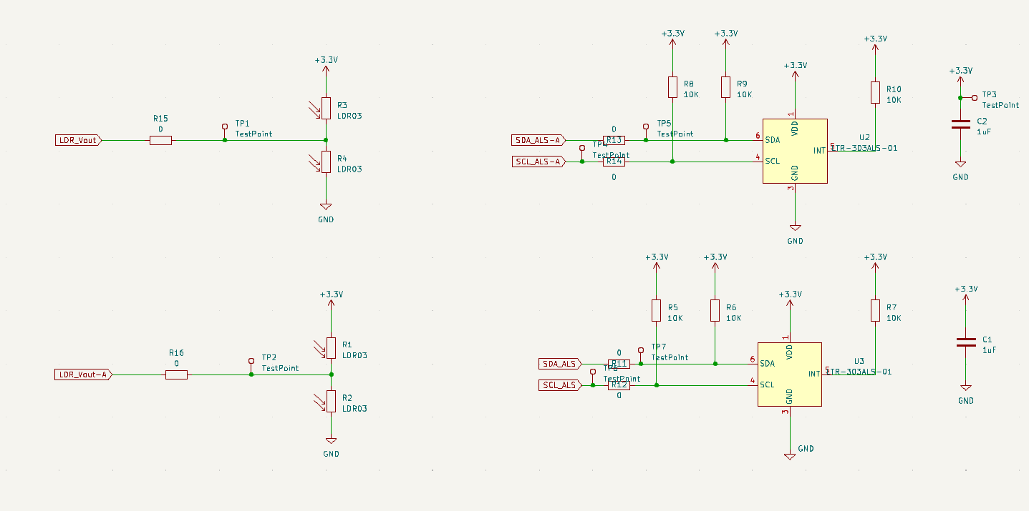

Q3.3 – Interface

Q3.3.1 – Digital Sensor Interface

The digital sensor will measure the ambient light levels of the surroundings from 0.1 Lux to 64K Lux and return the value as a 16 bit integer through the SDA_ALS line connected to pin 6 to the microcontroller unit (I2C Communication). The microcontroller will provide the SCL_ALS through pin 4 to the sensor.

Q3.3.2 – Analogue Sensor Interface

The analogue sensor will interface with the microcontroller through the LDR_Vout line connected to the ADC of the microcontroller. The LDR voltage divider will provide directional information on the light.